Line Follower Robot



***Abstract*— *The line follower robot incorporates the ability to follow the line draw on the floor. It is controlled using mobile machine. This model proposes the adaptation of ultrasonic sensors that enhances the ability of robot to detect the line as fast as possible.IR sensor is attached to robot so as it detects the obstacle in its path.***

***In this paper we present our proposed Line follower robot using IR and ultrasonic sensor.***

***Keywords— IoT , IR sensor , ultrasonic sensor***

1. INTRODUCTION

A line follower robot is a system which basically follow or trace black line on surface. we have made the use of sensors to achieve the objective .In this sensor IR and ultrasonic sensor are used .Both sensors are along in nature .The main advantage of the line follower property is that the vehicle can drive properly. A line follower robot can be used in many fields for example transport a building material and also a health care management system. IOT provides solutions for various problems and it allows things to be sensed or controlled remotely in network infrastructure. This kind of robot can be used for military purposes.

The remainder of this paper is organized as follows: 1. The detailed information about the line follower robot structure and architecture are discussed in this section. 2. Literature review 3. Results and discussion .

1. LITERATURE REVIEW
2. INTERNET OF THINGS

IoT helps people and things to be connected anytime, anyplace, with anyone, ideally using any network and any service. Automation is another important application of IoT technologies. It helps to monitor and control the garden environment by using different types of sensors and actuators that control lights, temperature, and humidity, moisture, soil pH. he Internet of Things (IoT) is a system of interrelated computing devices, mechanical and digital machines, objects, animals or people that are provided with unique identifiers and the ability to transfer data over a network without requiring human-to-human or human-to-computer interaction Smart phones, internet, televisions, sensors and actuators are connected to the internet where the devices are intelligently linked together which enables them a new form of communication. This happens amongst people and themselves with the help of IoT [2].

IoT is a network of interconnected devices with advanced capabilities to interact with each other, human beings, their surrounding physical world to perform different tasks.

1. Smart Line follower Robot

The line follower robot incorporates the ability to follow the line drawn on the floor. It is controlled by using mobile machine. This model proposes the adoption of ultrasonic sensor that enhances the ablility of robot to detect the line as fast as possible. IR sensor is attached to robot so as its detects the obstacle in its path.

III. RESULTS AND DISCUSSION

# Arduino UNO:

The Arduino UNO is an open-source microcontroller board based on the [Microchip](https://en.wikipedia.org/wiki/Microchip_Technology) [ATmega328P](https://en.wikipedia.org/wiki/ATmega328P) microcontroller .he board is equipped with sets of digital and analog input/output (I/O) pins that may be interfaced to various expansion boards (shields) and other circuits.[[1]](https://en.wikipedia.org/wiki/Arduino_Uno#cite_note-Makerspace-1) The board has 14 Digital pins, 6 Analog pins, and programmable with the Arduino IDE (Integrated Development Environment) via a type B USB cable. It can be powered by a USB cable or by an external 9 volt battery, though it accepts voltages between 7 and 20 volts. It is also similar to the Arduino Nano and Leonardo. The hardware reference design is distributed under a [c](https://en.wikipedia.org/wiki/Creative_Commons)reative commons Attribution Share-Alike 2.5 license and is available on the Arduino website. Layout and production files for some versions of the hardware are also available. "Uno" means one in Italian and was chosen to mark the release of Arduino Software (IDE) 1.0.

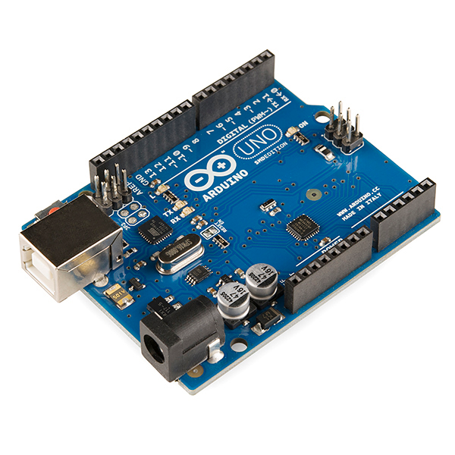fig 2. Arduino UNO

# IR Sensor:

An infrared sensor is an electronic instrument that is used to sense certain characteristics of its surroundings. It does this by either emitting or detecting infrared radiation. Infrared sensors are also capable of measuring the heat being emitted by an object and detecting motion A transmission medium is required for infrared transmission, which can be comprised of either a vacuum, the atmosphere or an optical fiber. Next, infrared detectors are used to detect the radiation which has been focused. The output from the detector is usually very small and hence pre-amplifiers coupled with circuitry are required to further process the received signals

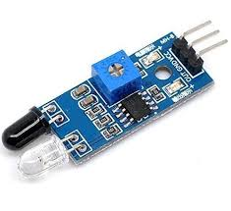

Fig 3. IR sensor

C. Ultrasonic Sensor:

**Ultrasonic transducers** or **ultrasonic sensors** are a type of acoustic sensor divided into three broad categories: transmitters, receivers and transceivers. Transmitters convert electrical signals into ultrasound receivers convert ultrasound into electrical signals, and transceivers can both transmit and receive ultrasound. Ultrasonic detection is most commonly used in industrial applications to detect hidden tracks, discontinuities in metals, composites, plastics, ceramics, and for water level detection. For this purpose the laws of physics which are indicating the propagation of sound waves through solid materials have been used since ultrasonic sensors using sound instead of light for detection.

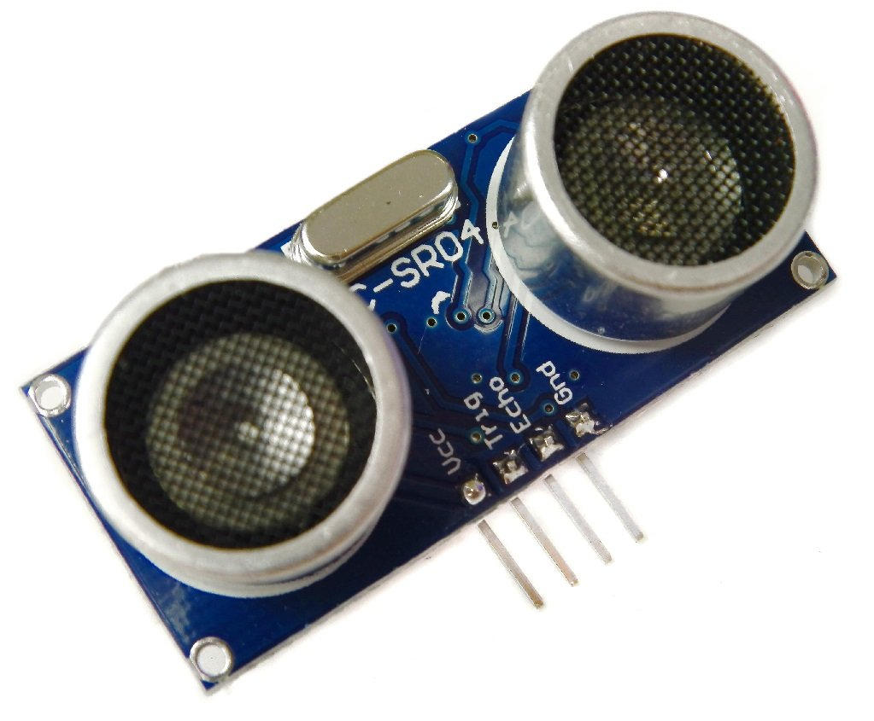

Fig 4.Ultrasonic sensor

V. Conclusion

The concept of the line follower robot is practically implemented in this paper by using Arduino UNO ,IR sensor, Ultrasonic sensor. Line follower robot makes use of instruction from sensors and with the help of motor physical movements are performed.

1. REFERENCES
2. Robert AG. Suciu, S. Halunga, A. Vulpe, V. Suciu (2013). Generic platform for IoT and cloud computinginteroperability study, Signals, Circuits and Systems(ISSCS), 2013 International Symposium, pp.1,4, 11-12 July 2013.
3. J. Jin, J. Gubbi, S. Marusic, and M. Palaniswami, “An information framework for creating a smart city through internet of things,” IEEE Internet of Things Journal, vol. 1, no. 2, pp. 112–121, 2014.
4. ] S. Escolar, J. Carretero, M.-C. Marinescu, and S. Chessa, “Estimating energy savings in smart street lighting by using an adaptive control system,” International Journal of Distributed Sensor Networks, vol. 10, no. 5, p. 971587, 2014.
5. R. M¨ullner and A. Riener, “An energy efﬁcient pedestrian aware smart street lighting system,” International Journal of Pervasive Computing and Communications, vol. 7, no. 2, pp. 147–161, 2011.
6. T. Braunl, Embedded Robotics: Mobile Robot Design and Applications With Embedded Systems. Springer-Verlag, 2nd edition edition, 2006.
7. Lee, C.-S., Su, J.-H., Lin, K.-E., Chang, J.-H., Chiu,

M.-H. and Lin, G.-H., A hands-on laboratory for

autonomous mobile robot design courses. *Proc. 17th*

*Inter. Federation of Automatic Control World*

*Congress*, Korea, pp.473-9,478 Sept. 2008.

1. C. Cardeira, J.S. Da Costa, "A low cost mobile robot

for engineering education," *Industrial Electronics*

*Society, 2005. IECON 2005. 31st Annual Conference*

*of IEEE* , 6-10 Nov. 2005

1. Konaka, E., Suzuki, T., Okuma, S, “Line-following

control of two wheeled vehicle by a symbolic control,”

*Proc. of the 40th IEEE Conference on Decision and*

*Control*, Orlando, USA, Dec. 4 - 7, 2001.

1. J. Dupuis, and M. Parizeau, “Evolving a Vision-Based

Line-Following Robot Controller” *In Proceedings of*

*the The 3rd Canadian Conference on Computer and*

*Robot Vision*, *IEEE Computer Society,* pp. 75-79.

Washington, DC, USA 2006.